**广西2020年上学期桂林十八中高三英语第一次月考试题答案**

**听力：**

**CACBC CACAA CBBAB ACCCA**

**阅读：**

**B C A CBAB CDAB BDCD E F G A D**

**完型:**

**BDACD ACBCD BDABA CBADC**

**语法填空：**

**61.set 62.largest 63.was founded 64.on/upon 65.them 66.hasestablished 67.respectively 68.marking 69.countries 70.an**

**第一节 短文改错**

I am writing to offer my sincere．You won the first prize in the Chinese Chess Network Challenge．As your friend，I just want you to know how I am at your success．

In  last few years，you shown great interest in Chinese chess．You keep on practicing  every day．Not only have you read books about Chinese chess strategies，but also you have competed  all kinds of Chinese chess contests．Finally，you succeeded in  the online competition!

I was so ~~very~~ happy that I couldn’t go to sleep last night．I’m eager to play Chinese chess with you at the community club，*/in which* we’11 enjoy ourselves．

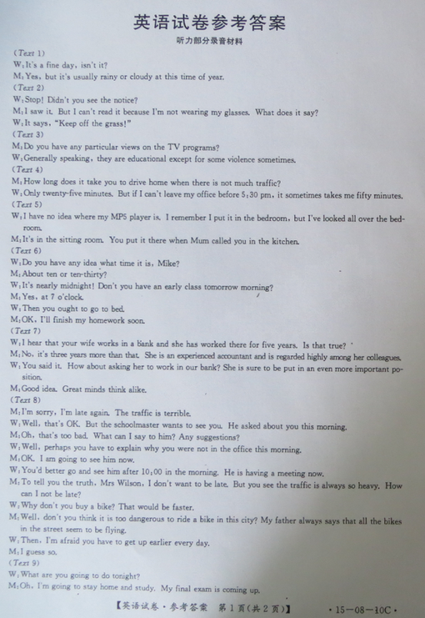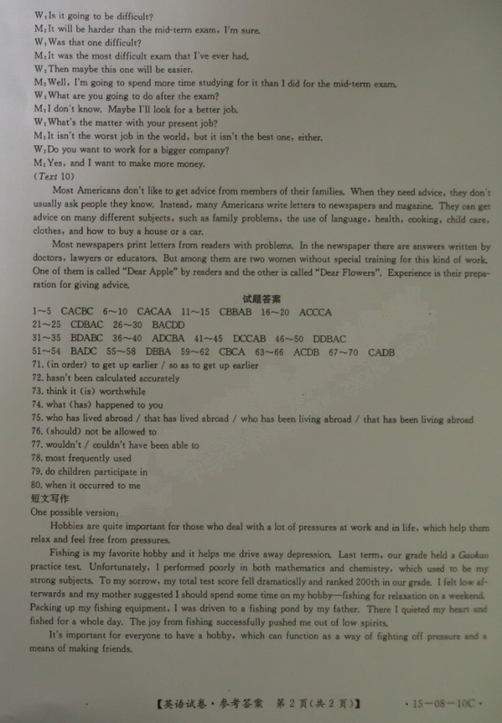

欢迎访问“高中试卷网”——http://sj.fjjy.org